**FULL STACK PROJECT**

<?php include("content.php");?>

<!DOCTYPE html>

<html>

<head>

<meta charset="utf-8">

<meta name="viewport" content="width=device-width,initial-scale=1">

<title>REGISTRATION FORM</title>

<style type = "text/css">

label{

width:100px;

display:inline-block;

}

body

{

background-color: hsl(35,85%,52%);

}

</style>

</head>

<body>

<div class="container">

<form action="#" method="POST">

<div class="title">

<h2>

<center>

REGISTRATION FORM

</center>

</h2>

</div>

<hr width="480" align="left">

<div class="form">

<div class="input_field">

<label>First Name</label>

<input type="text" class="input" name="fname"required>

</div><br>

<div class="input_field">

<label>Last Name</label>

<input type="text" class="input" name="lname"required>

</div> <br>

<div class="input_field">

<label>Age</label>

<input type="text" class="input" name="age"required>

</div> <br>

<div class="input_field">

<label style="margin-right: 5px;">Gender</label>

<input type="radio" name="r1" value="female" required><label style="margin-left: 5px;">Female</label>

<input type="radio" name="r1" value="male" required><label style="margin-left: 5px;">Male</label>

<input type="radio" name="r1" value="others" required><label style="margin-left: 5px;">Others</label>

</div> <br>

<div class="input_field">

<label>Course</label>

<div class="custom_select">

<select name="course" required>

<option value="">Select</option>

<option value="BCA">BCA</option>

<option value="BSc IT">BSc IT</option>

<option value="MCA">MCA</option>

<option value="BBA">BBA</option>

</select>

</div>

</div> <br>

<div class="input_field">

<label>Email Address</label>

<input type="text" class="input" name="email" required>

</div> <br>

<div class="input_field">

<label>Phone Number</label>

<input type="text" class="input" name="phone" required>

</div> <br>

<div class="input_field">

<label style="margin-right: 5px;">Language</label>

<input type="checkbox" name="language[]" value="English"><label style="margin-left: 5px;">English</label>

<input type="checkbox" name="language[]" value="Tamil"><label style="margin-left: 5px;">Tamil</label>

<input type="checkbox" name="language[]" value="Hindi"><label style="margin-left: 5px;">Hindi</label>

</div> <br>

<div class="input_field">

<label>Address</label> <br><br>

<textarea class="textarea" name="address" required></textarea>

</div> <br><br>

<hr width="480" align="left">

<div class="input_field">

<input type="submit" value="Register" class="btn" name="register">

</div>

</div>

</form>

</div>

</body>

</html>

<?php

if($_POST['register'])

{

$fname = $_POST['fname'];

$lname = $_POST['lname'];

$age = $_POST['age'];

$gender = $_POST['r1'];

$course = $_POST['course'];

$email = $_POST['email'];

$phone = $_POST['phone'];

$lang = $_POST['language'];

$lang1 = implode(",",$lang);

$address = $_POST['address'];

$query = "INSERT INTO form2 (fname,lname,age,gender,course,email,phone,language,address) VALUES('$fname','$lname','$age','$gender','$course','$email','$phone','$lang1','$address')";

$data = mysqli_query($conn,$query);

if($data)

{

echo "Data Inserted into Database";

}

}

?>

**CONTENT.PHP**

<?php

$sname = "localhost";

$uname = "root";

$password = "";

$db_name = "srinidhi";

$conn = mysqli_connect($sname, $uname, $password, $db_name);

if(!$conn){

echo "connection failed!";

exit();

}

?>

FRONTEND:

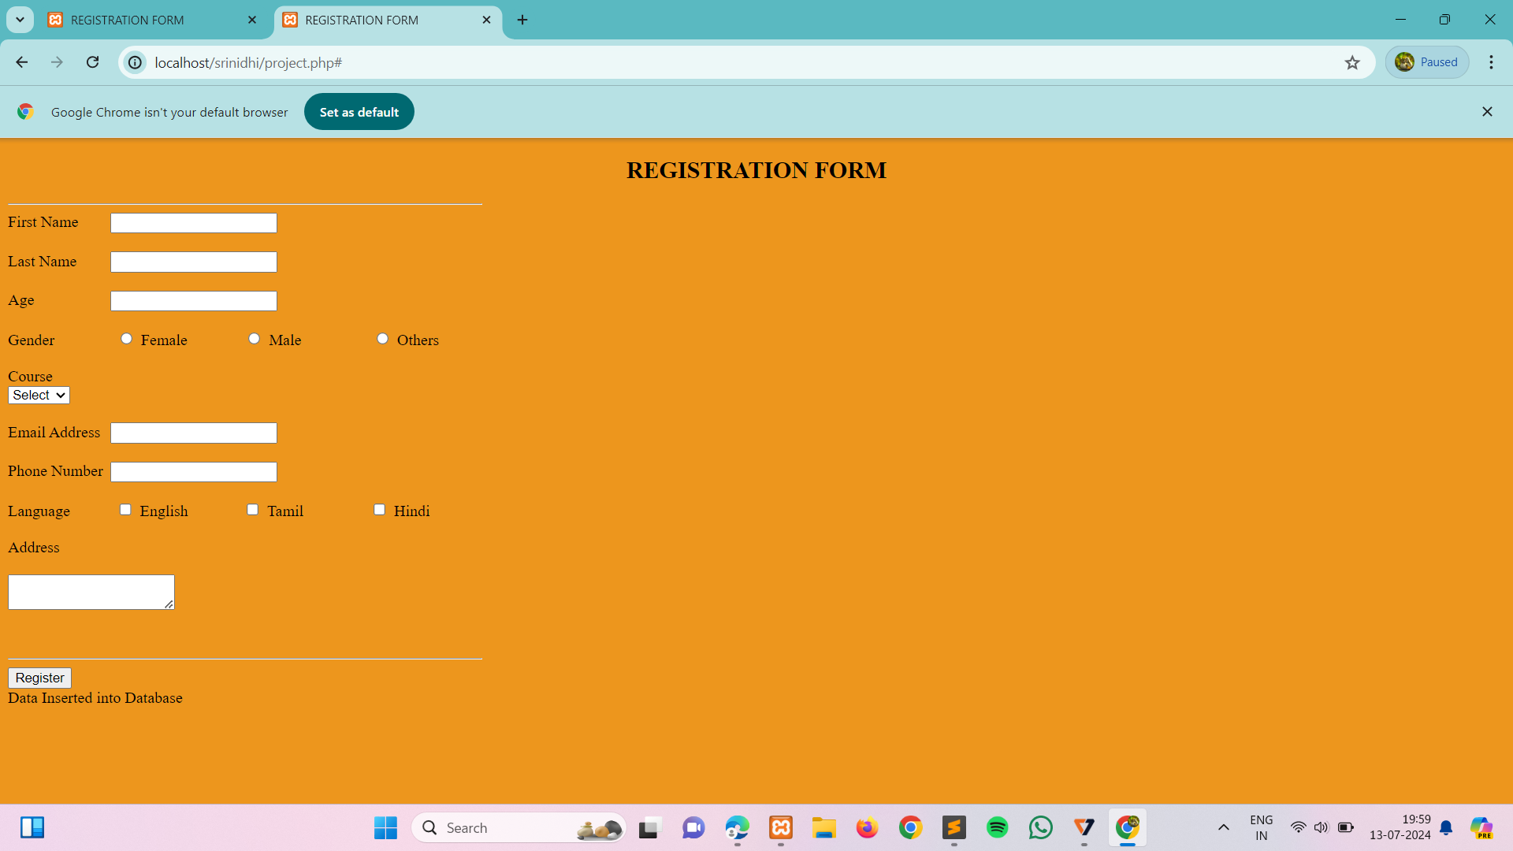

BACKEND:

